REGIONAL BOARD MEETING

There will be a meeting of the Borders College Regional Board on Thursday 21 April 2022 at 17:30 via Teams.

AGENDA

Paper

21/22 Chair’s Opening Remarks

22/22 Apologies for Absence

23/22 Minutes Board Meeting held on 3 March 2022 A

24/22 Matters Arising

25/22 Declaration of any Conflicts of Interest/Register of Interests Update

26/22 Review of Board Business (R McCowan) B

27/22 Budget Presentation (H Robertson)

28/22 Cyber Resilience Workshop (H Robertson)

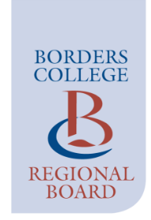
29/22 Date of Next Meeting – 16 June 2022

