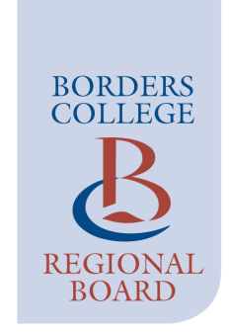

CURRICULUM & QUALITY COMMITTEE

The next meeting of the Curriculum & Quality Committee will take place
at 16:30 on Thursday 9 June 2022 via Teams

AGENDA
Paper

18/22 Chair’s Opening Remarks

19/22 Apologies for Absence

20/22 Minutes of Meeting held on 17 February 2022 A
21/22 Matters Arising

22/22 Declaration of any Conflicts of Interest / Register of Members Interest

23/22 Curriculum Development Presentation (J Cairney, CLM Early Education & Supported Programmes)
24/22 Equality Action Plan Progress - Annual (A Brydon) B

ITEMS FOR DISCUSSION

25/22 Update on 2020-2021 KPIs, Completers 2021-2022, Credits
& Admissions Update (A Sturrock) C

26/22 Strategic Risk Register (H Robertson) D

ITEMS FOR INFORMATION

27/22 Quality & Development Update: (J Gracie) E

- Student Satisfaction & Engagement Survey 2021-22
- Annual Approvals Report
- Complaints & Compliments Report
- Enhancement and Self-Evaluation Plan Progress Update

28/22 BCSA Update (S Prentice) F

29/22 Learning for Leading (A Sturrock) G

30/22 Papers for Publication

31/22 Any Other Business

32/22 Date of Next Meeting – 16:30 on Thursday 6 October 2022

